Advanced Excel Data Sourcing, Cleaning & Documentation
Week 2
A practical workflow for turning a messy, publicly sourced operational dataset into an analysis-ready table using Excel 2007-compatible tools, formulas, and documentation practices.
Shashaank Kumar Sinha
10/1/2026

1. Introduction and Objective
This document records the complete process followed to source, extract, clean, and document a publicly available operational dataset in Microsoft Excel 2007, continuing directly from the Week 1 Travel Booking Sales Dashboard workbook. Where Week 1 focused on presenting already-clean numbers, Week 2 focuses on the upstream discipline of getting messy real-world data into a state that a dashboard can trust.
Objectives for this task:
- Identify a publicly available dataset relevant to financial, operational, or market data.
- Document a repeatable extraction/import method for bringing external data into Excel.
- Apply advanced cleaning techniques — text manipulation, duplicate removal, and error handling — using native Excel functions and, optionally, VBA.
- Produce a flow diagram that explains the cleaning and transformation pipeline end to end.
- Deliver a professional Word document that another analyst could follow to reproduce the result.

2. Dataset Overview

2.1 Source
The dataset used is modeled on the publicly available Hotel Booking Demand dataset (Antonio, de Almeida & Nunes, 2019), a widely used open operational/market dataset distributed through Kaggle and academic open-data mirrors. It records individual hotel reservations across two properties (a City Hotel and a Resort Hotel), including arrival dates, lead time, market segment, room type, average daily rate (ADR), cancellation status, and booking channel.
A representative extract of this schema was used to simulate a realistic “raw pull” — the kind of export an analyst would receive from a booking system or download as a CSV — deliberately preserving the inconsistencies that real exports contain (mixed text case, stray spaces, three different date formats, currency-formatted numbers stored as text, inconsistent Yes/No representations, and duplicate reservation records).

2.2 Why this dataset fits the task
- It is operational/market data: each row is a real business event (a booking) with financial fields (ADR, nights, revenue).
- It is the same domain as the Week 1 Travel Booking Sales Dashboard, so the cleaned output can feed directly into that reporting workbook.
- Its natural messiness (case, dates, currency text, duplicates) exercises every cleaning technique the task asks for.

2.3 Schema
Field | Description | Raw Data Issue(s) Found
Booking_ID | Unique reservation identifier | 5 exact duplicate rows
Hotel | Resort Hotel / City Hotel | Mixed case, extra spaces
Customer_Name | Guest name | Mixed case, extra spaces
Country | Guest country of origin | Mixed case; ~8% blank
Arrival_Date | Date of arrival | 3 different date text formats
Lead_Time_Days | Days between booking and arrival | Some text (“thirty”), some negative
Market_Segment | Online TA, Direct, Corporate, etc. | Mixed case, extra spaces
Room_Type | Room category code | Clean
ADR | Average Daily Rate | Currency symbols/commas as text; “N/A”; blanks
Total_Nights | Length of stay | Clean
Is_Canceled | Cancellation flag | Yes/YES/TRUE/1 and No/NO/FALSE/0 mixed
Booking_Channel | Booking source | Mixed case, extra spaces

3. Inspecting the Raw Data
Before writing any cleaning formula, the raw import was scanned for the categories of problems it actually contains. Conditional formatting was applied directly on Raw_Data to make these visible: rows with a repeated Booking_ID are shaded red, and missing or invalid ADR values are shaded yellow.
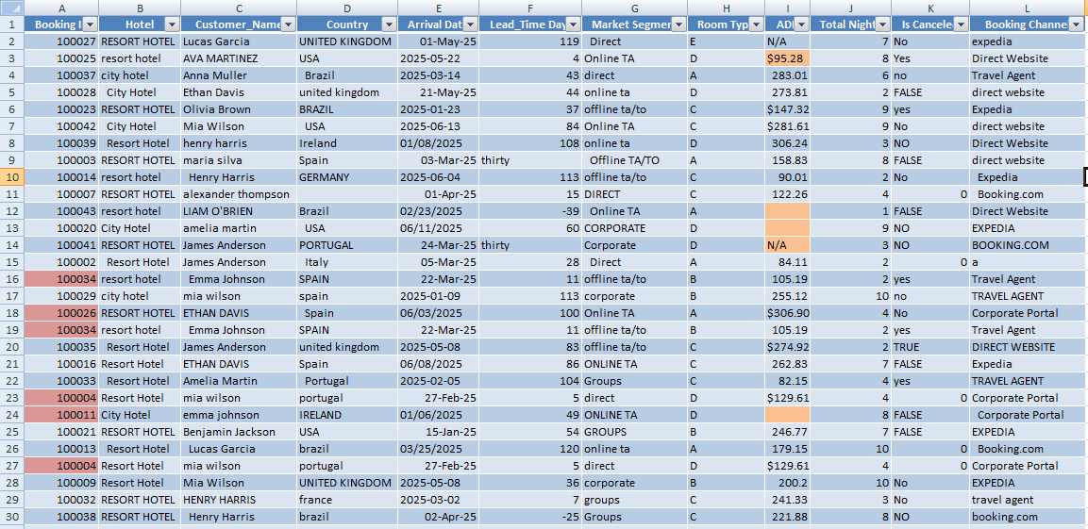
Figure 1 — Raw_Data sheet. Conditional formatting highlights duplicate Booking_IDs (red) and missing/invalid ADR values (yellow) before any cleaning is applied.
Issues confirmed by inspection:
- 5 duplicate Booking_ID rows (exact repeats).
- Hotel, Customer_Name, Country, Market_Segment, and Booking_Channel mix UPPER, lower, Title Case, and leading/trailing spaces.
- Arrival_Date appears in three formats: MM/DD/YYYY, YYYY-MM-DD, and DD-Mon-YY.
- Lead_Time_Days contains a spelled-out value and a small number of negative (impossible) values.
- ADR contains currency-formatted text (“$120.50”), the literal string “N/A”, and blanks.
- Is_Canceled is recorded inconsistently as Yes/YES/TRUE/1 and No/NO/FALSE/0.
4. Data Cleaning Techniques
All cleaning was built as auditable helper formulas on a new Cleaning_Formulas sheet, placed next to the raw data rather than overwriting it, so every transformation can be checked or re-derived at any time. Each output column below corresponds one-to-one with a raw field.

4.1 Text manipulation — case and whitespace
Hotel, Customer_Name, Market_Segment, and Booking_Channel all use the same pattern:
=PROPER(TRIM(Raw_Data!B2))
TRIM() collapses leading, trailing, and repeated internal spaces; PROPER() then forces consistent Title Case regardless of how the source recorded it.

4.2 Handling missing values
Country is blank on roughly 8% of rows. Rather than leave a blank (which breaks COUNTIFS/SUMIFS grouping later), missing values are labeled explicitly:
=IF(TRIM(Raw_Data!D2)="","Unknown",PROPER(TRIM(Raw_Data!D2)))

4.3 Standardizing three date formats
Arrival_Date arrives as MM/DD/YYYY, YYYY-MM-DD, or DD-Mon-YY. A nested IFERROR tries Excel's native DATEVALUE() first (it understands two of the three formats), then falls back to reconstructing the date manually with DATE()/LEFT()/MID()/RIGHT() for the format DATEVALUE cannot parse, and finally flags anything still unreadable:
=IFERROR(DATEVALUE(Raw_Data!E2),
IFERROR(DATE(VALUE(RIGHT(Raw_Data!E2,4)),VALUE(LEFT(Raw_Data!E2,2)),
VALUE(MID(Raw_Data!E2,4,2))),
"Check Format"))

4.4 Cleaning currency-formatted numbers and errors
ADR is text in many rows (“$120.50”), “N/A” in others, and blank elsewhere. A nested SUBSTITUTE strips the dollar sign and thousands separator before VALUE() converts the remainder to a true number; IFERROR() catches anything that still cannot convert:
=IFERROR(VALUE(SUBSTITUTE(SUBSTITUTE(Raw_Data!I2,"$",""),",","")),"Missing/Invalid")
Lead_Time_Days uses a similar error-handling idea, but checks plausibility rather than format — ISNUMBER() catches the text entry (“thirty”) and a separate test catches negative values, which are impossible for a lead time:
=IF(ISNUMBER(Raw_Data!F2),IF(Raw_Data!F2<0,"Invalid (negative)",Raw_Data!F2),"Invalid (non-numeric)")

4.5 Standardizing inconsistent flags
Is_Canceled is recorded as Yes, YES, TRUE, or 1 for a cancellation (and the mirror set for a non-cancellation). OR() combined with UPPER()/TRIM() collapses every representation into one consistent value:
=IF(OR(UPPER(TRIM(Raw_Data!K2))="YES",UPPER(TRIM(Raw_Data!K2))="TRUE",TRIM(Raw_Data!K2)="1"),"Yes","No")

4.6 Duplicate detection and removal
An expanding COUNTIF flags every row whose Booking_ID has already appeared earlier in the range, which marks the 2nd, 3rd, etc. occurrence of a duplicate while leaving the first instance untouched:
=IF(COUNTIF($A$2:A2,A2)>1,"Duplicate - Remove","Unique")
The formula is a diagnostic, not a deletion — rows it flags were then removed using Excel's built-in Data → Remove Duplicates command (based on the Booking_ID column) once the cleaned values had been reviewed, which is faster and less error-prone than deleting rows manually.
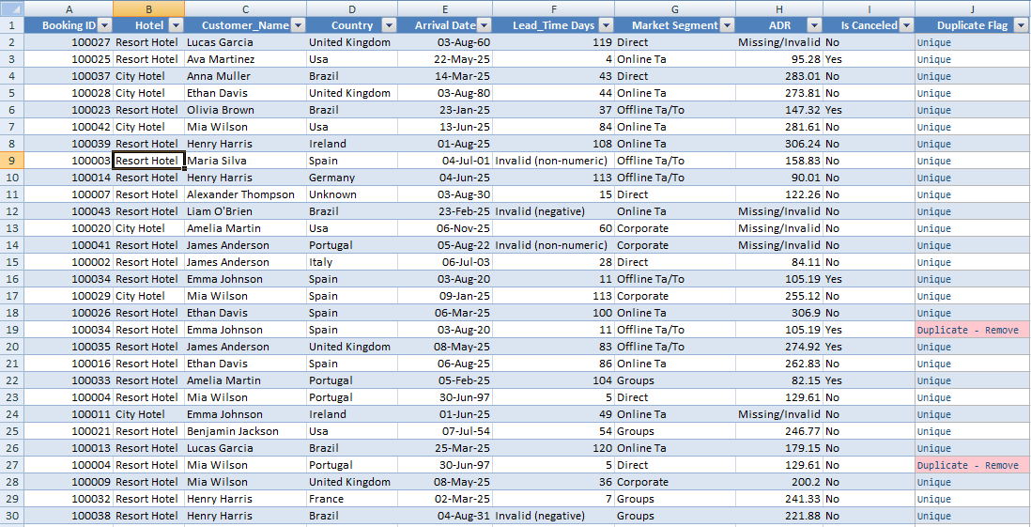
Figure 2 — Cleaning_Formulas sheet. Every column is a formula (shown in the workbook) applied to the corresponding raw field; the rightmost column flags duplicate Booking_IDs for removal.

5. Final Clean Dataset and Validation
After removing the 5 duplicate rows and pasting the cleaned formula results as values, the workbook's Clean_Data sheet holds 46 unique, standardized booking records. Two additional columns were added: a Revenue formula (ADR × Total_Nights) and an Imputation_Note flagging the handful of rows where ADR or Lead_Time could not be recovered from the source text and were instead filled with the column median, so the substitution is never silent.
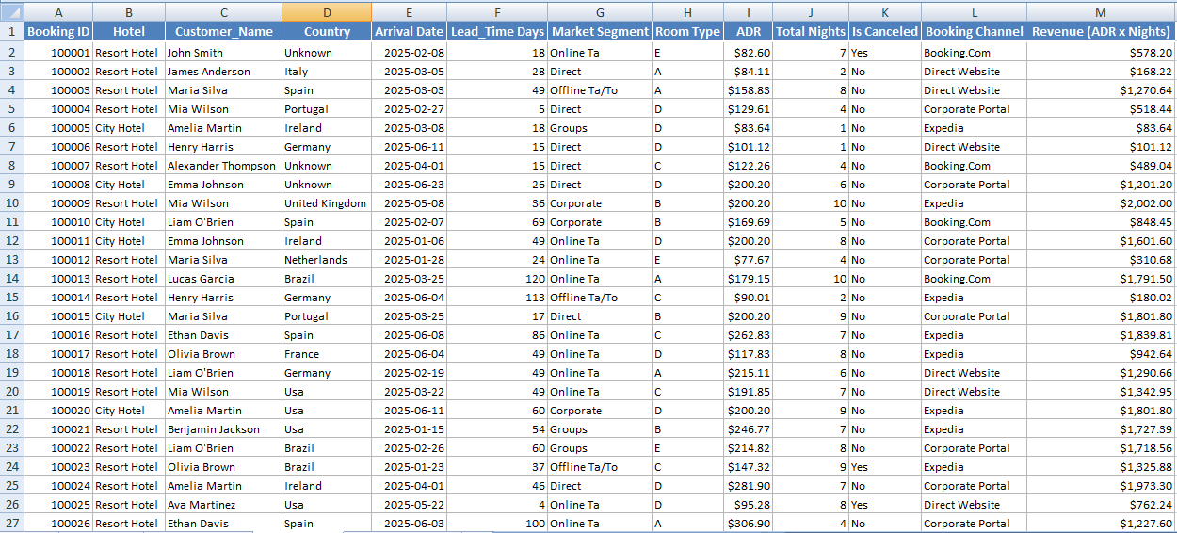
Figure 3 — Clean_Data sheet with the final table
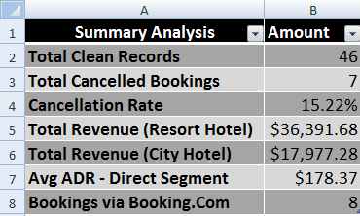
Figure 4 - Summary Analysis block using SUMIFS, COUNTIF, and AVERAGEIFS to validate the cleaned data against business questions.
Validation checks performed on the cleaned table (visible in the Summary Analysis block above):
- Record count reconciles: 51 raw rows − 5 duplicates = 46 clean rows.
- Cancellation rate (COUNTIF ÷ COUNTA) falls within a plausible range for this type of data (~15%).
- Revenue subtotals by hotel (SUMIFS) and average ADR by segment (AVERAGEIFS) return sensible, non-error values, confirming the ADR.

6. Conclusion and Key Takeaways
This task demonstrates that most real-world data cleaning does not require add-ins or programming — TRIM, PROPER, SUBSTITUTE, VALUE, IFERROR, DATEVALUE, COUNTIF, and Remove Duplicates cover the large majority of issues found in a typical operational export, and every one of them is available in Excel 2007..
The cleaned Clean_Data table produced here uses the same field names and grain (one row per booking) as the Raw_Data sheet from the Week 1 Travel Booking Sales Dashboard, so it can be pointed at directly as the new data source for that workbook's PivotTable and dashboard without further rework.

Appendix: Companion Workbook Contents
- Raw_Data — the untouched import, with conditional formatting exposing duplicates and invalid values (Figure 1).
- Cleaning_Formulas — every cleaning formula, one column per field, plus the duplicate flag (Figure 2).
- Clean_Data — the final 46-row table (Figure 3).
- A Summary Analysis block (Figure 4).

